Process to validate MIB traps on Delphix.

1. Install Trap Deamon capture package:
   1. <http://www.ireasoning.com/download/mibfree/mibbrowser.zip>
      1. Unzip and open Terminal
      2. Sudo as root
      3. Execute the shell trapd.sh

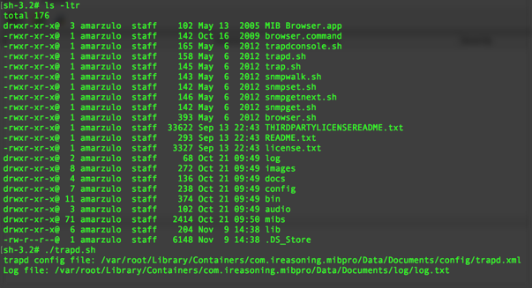

Root is necessary on Mac because this app will open an administrative port 162.

1. Configure Delphix Engine:
   1. Enter in Engine Setup;
   2. Configure SNMP to the IP of your computer:
      1. 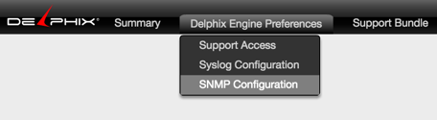
      2. 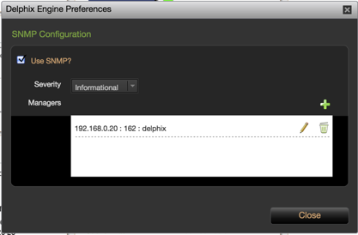
      3. 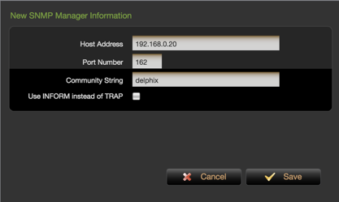
2. Enter em Delphix Admin console:
   1. Choose a dSource

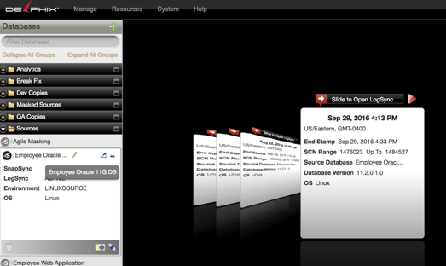

* 1. Run a Snapshot

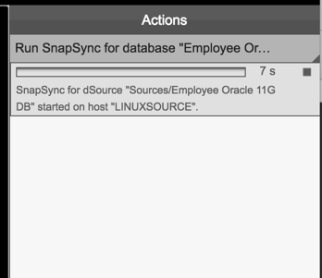

* 1. Check TrapD console

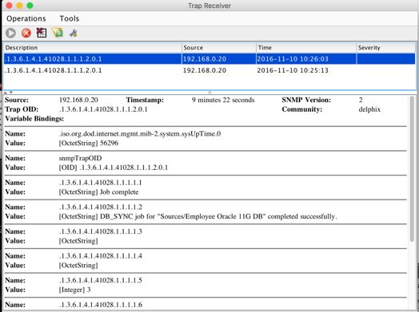

The Trap is generated after Job finishes.